Session13
1.
Create a table named Playlists with columns: id, user_id, playlist_name, and total_likes. Insert at least 8 sample rows with different users and playlists, making sure some playlists have the same user_id.
Ans :
USE demo;

DROP TABLE IF EXISTS Playlists;

CREATE TABLE Playlists (
id INT PRIMARY KEY,
user_id INT,
playlist_name VARCHAR(100),
total_likes INT
);

INSERT INTO Playlists VALUES
(1,101,'Workout Hits',500),
(2,101,'Morning Vibes',300),
(3,101,'Party Mix',700),
(4,102,'Love Songs',800),
(5,102,'Sad Songs',400),
(6,103,'Rock Classics',900),
(7,103,'Travel Playlist',600),
(8,104,'Study Music',500);

SELECT * FROM Playlists;
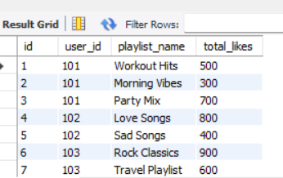
2.
Write a SQL query using ROW_NUMBER() and the OVER() clause to assign a unique row number to each playlist, ordered by total_likes in descending order.
Ans :
SELECT
playlist_name,
user_id,
total_likes,
ROW_NUMBER() OVER(ORDER BY total_likes DESC) AS row_number
FROM Playlists;

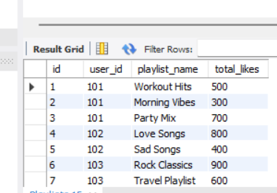
3.
Use the RANK() function with the OVER() clause to rank all playlists by total_likes, and display the playlist_name, user_id, total_likes, and their rank.
Ans :
SELECT
playlist_name,
user_id,
total_likes,
RANK() OVER(ORDER BY total_likes DESC) AS playlist_rank
FROM Playlists;
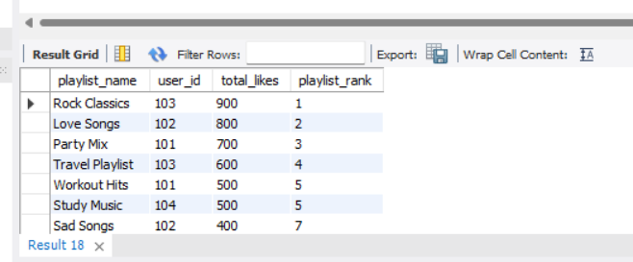
4.
Write a SQL query using DENSE_RANK() and PARTITION BY user_id to rank each user's playlists by total_likes, showing playlist_name, user_id, total_likes, and dense rank.<br><br><em><strong>Hint:</strong> This will show how popular each playlist is within each user's account, similar to how Spotify might rank your top playlists.</em>
Ans :
SELECT
playlist_name,
user_id,
total_likes,
DENSE_RANK() OVER (
PARTITION BY user_id
ORDER BY total_likes DESC
) AS playlist_rank
FROM Playlists;
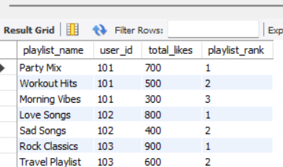
5.
Imagine you want to show the top 2 playlists per user based on total_likes, like Spotify's 'Your Top Playlists' feature. Write a query using a window function to select only the top 2 playlists for each user.
Ans :
WITH RankedPlaylists AS
(
SELECT
playlist_name,
user_id,
total_likes,
ROW_NUMBER() OVER(
PARTITION BY user_id
ORDER BY total_likes DESC
) AS row_num
FROM Playlists
)

SELECT
playlist_name,
user_id,
total_likes
FROM RankedPlaylists
WHERE row_num <= 2;

